**SERVERLESS-CLOUD(LAMBDA)**

**STEP 1:-**

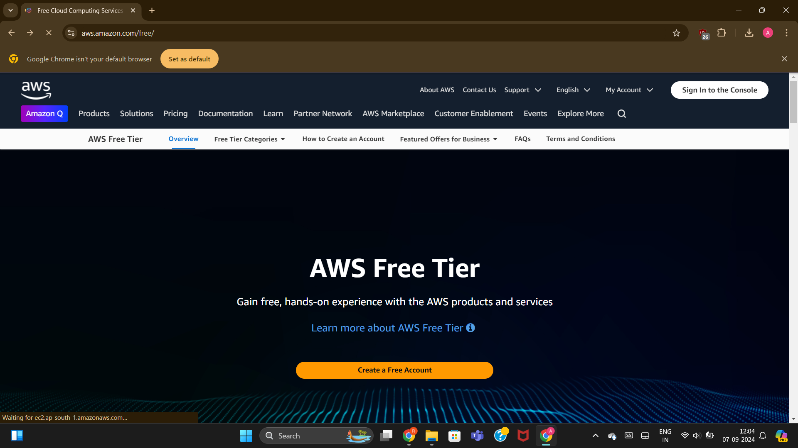

Firstly, open AWS free tier and then “sign in to the Console”.

**STEP 2 :-**

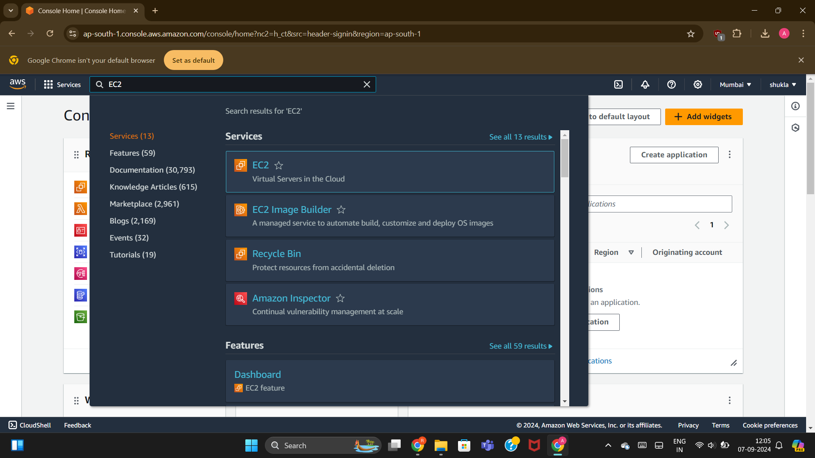

Then search for EC2 service of AWS for launching instances .

STEP 3:-

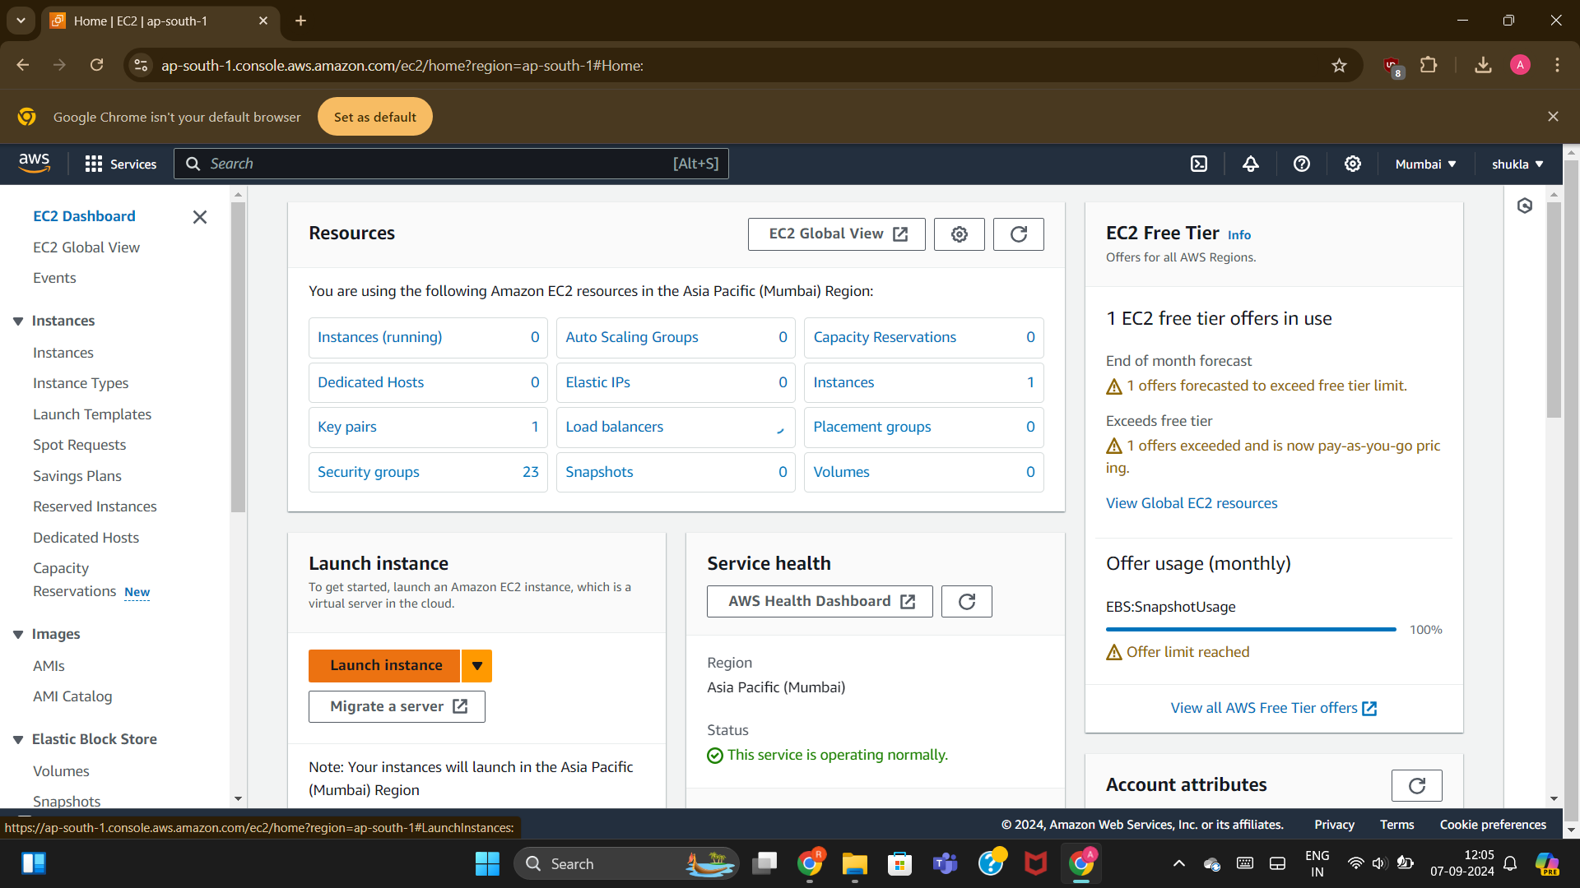

After that go to launch instances and there launch two servers of windows .

STEP 4:-

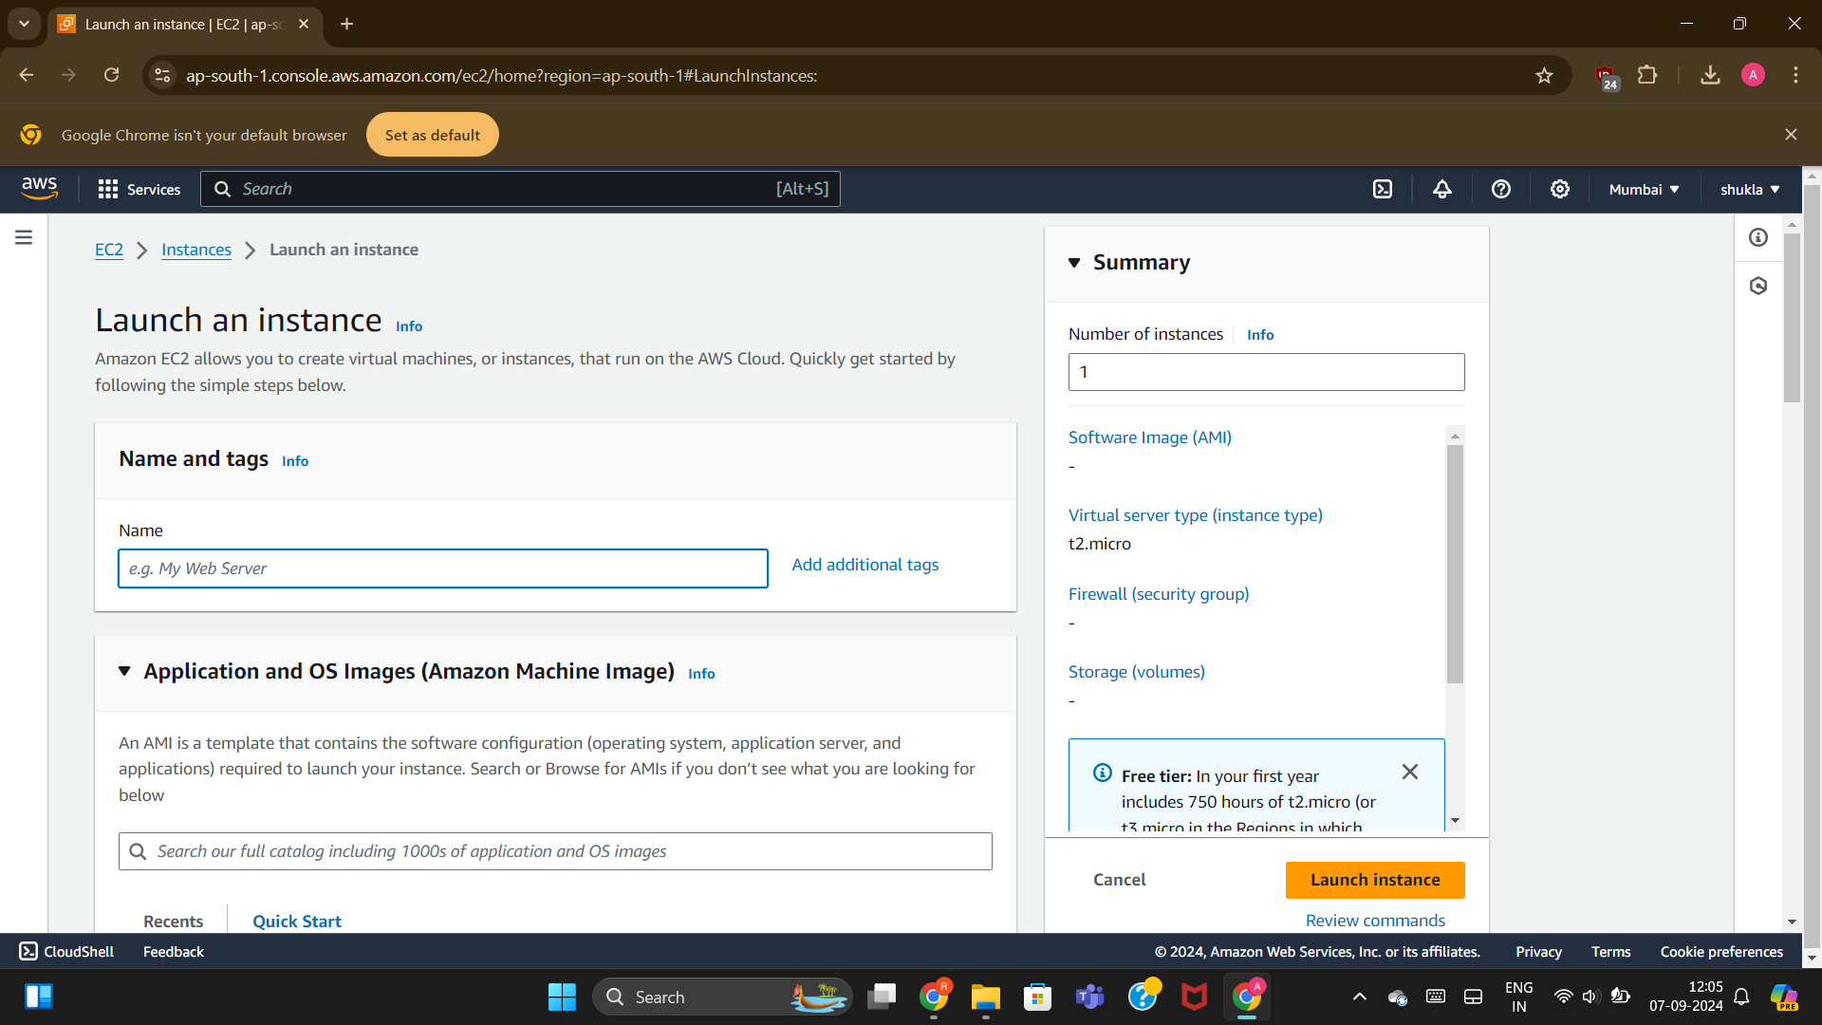

Mention the name of the server as server 1(or according to you).

STEP 5:-

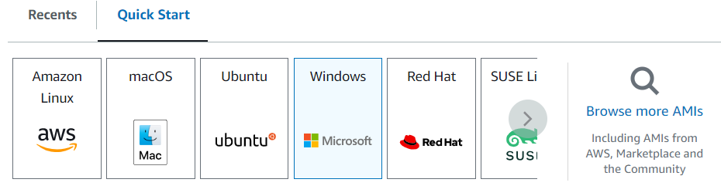

Select windows for the server1 created.

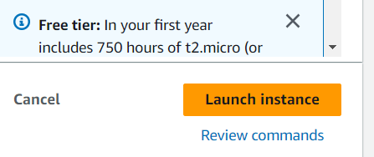

After crating a new key pair for the server and acknowledging the terms and conditions for the server click on the “launch instance”.

STEP 6:-

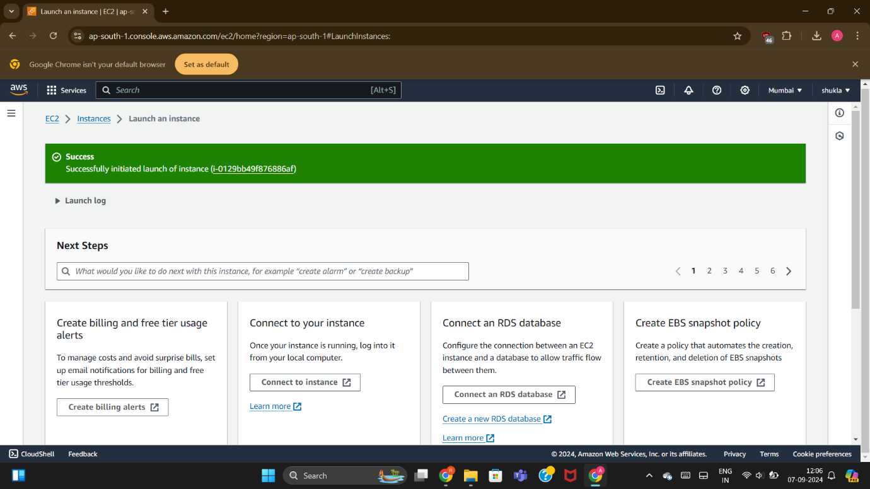

After launch instance it seems like this .

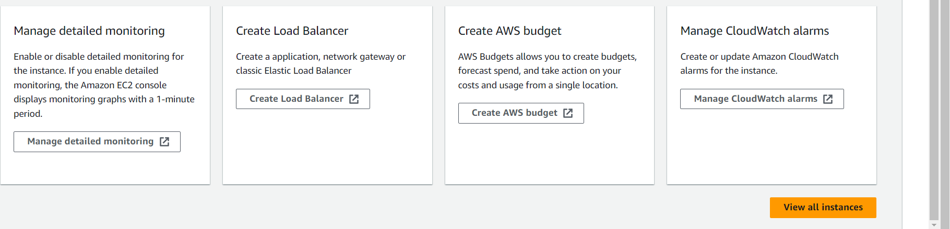

Click on the “view all instances ” in order to see the server being created.

STEP 7:-

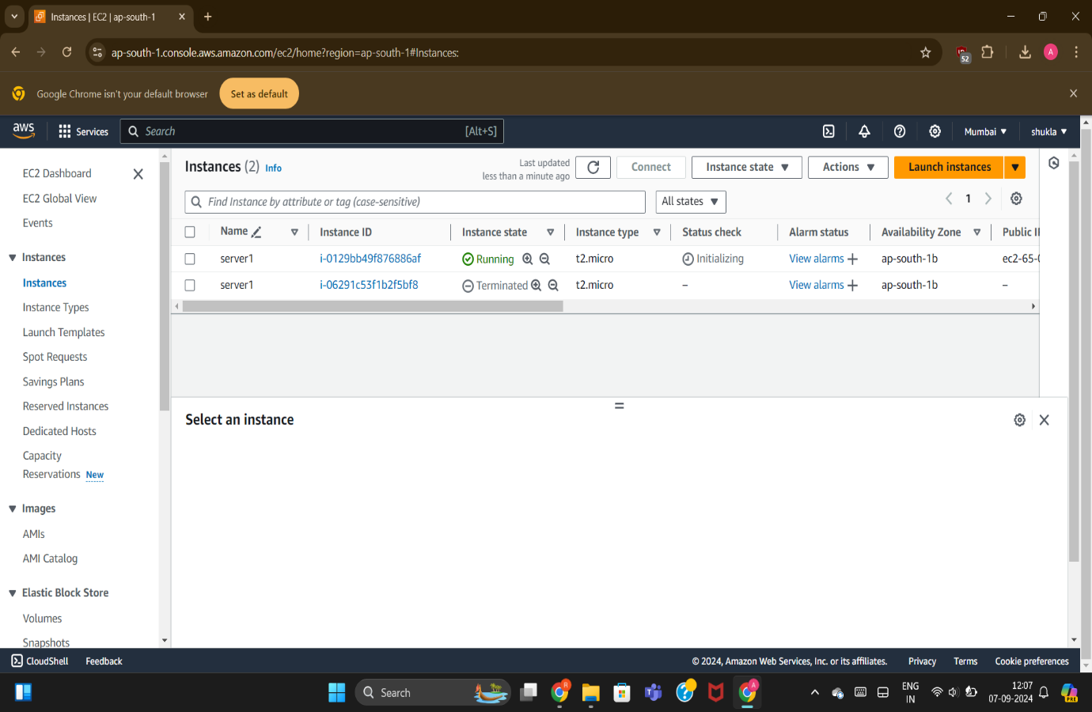

Server 1 is being launched similarly we have to launch another server named as “server2” in similar way.

STEP 8:-

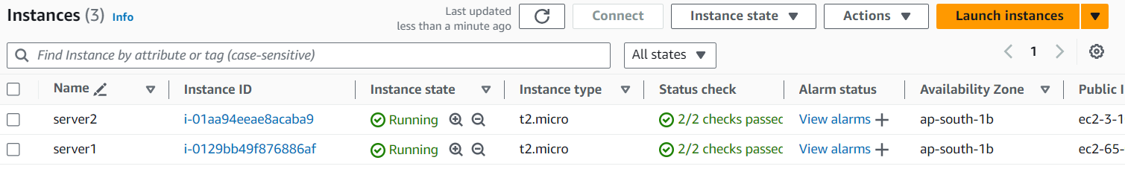

Both the servers are launched in the same region i.e. ap-south-1.

Till here we have completed our work regarding EC2 for server launch .

STEP 9:-

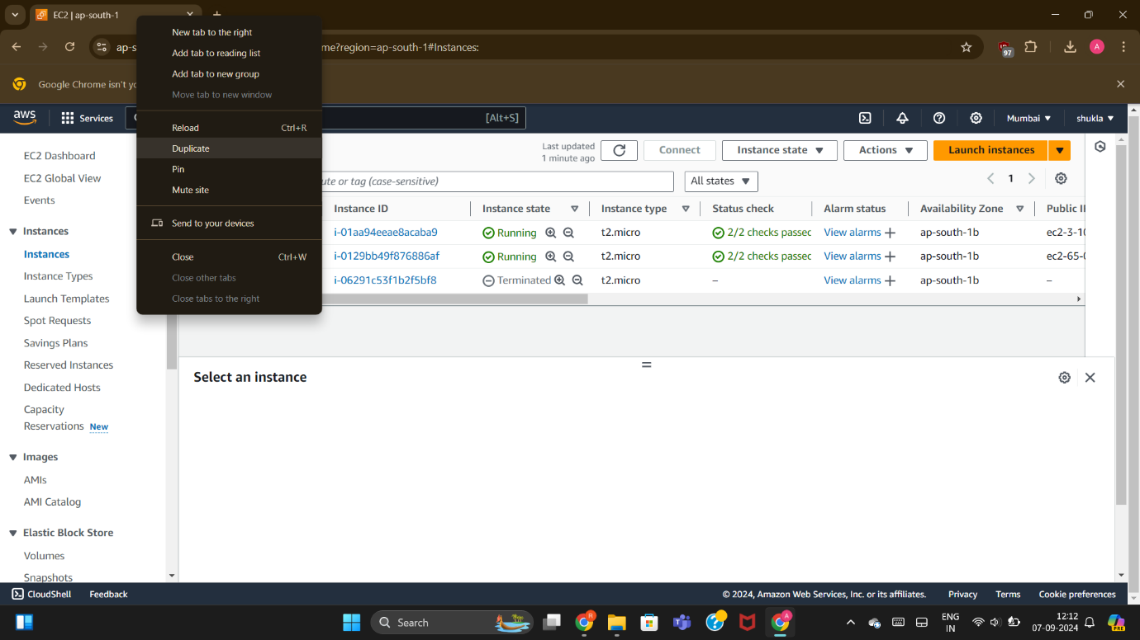

Now we will open a duplicate window for creating role using IAM.

STEP 10:-

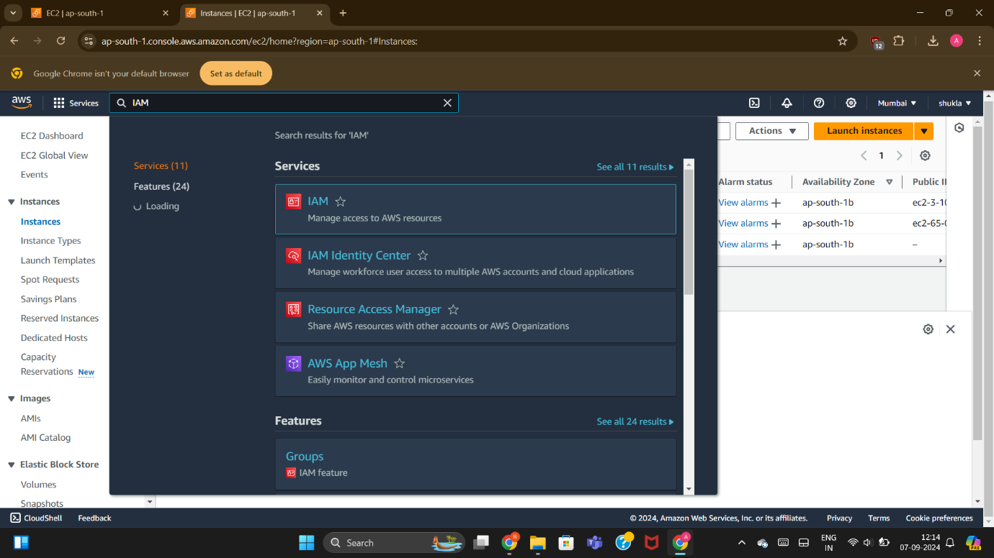

In the search bar we will search for another service of AWS i.e. IAM for creating role.

STEP 11:-

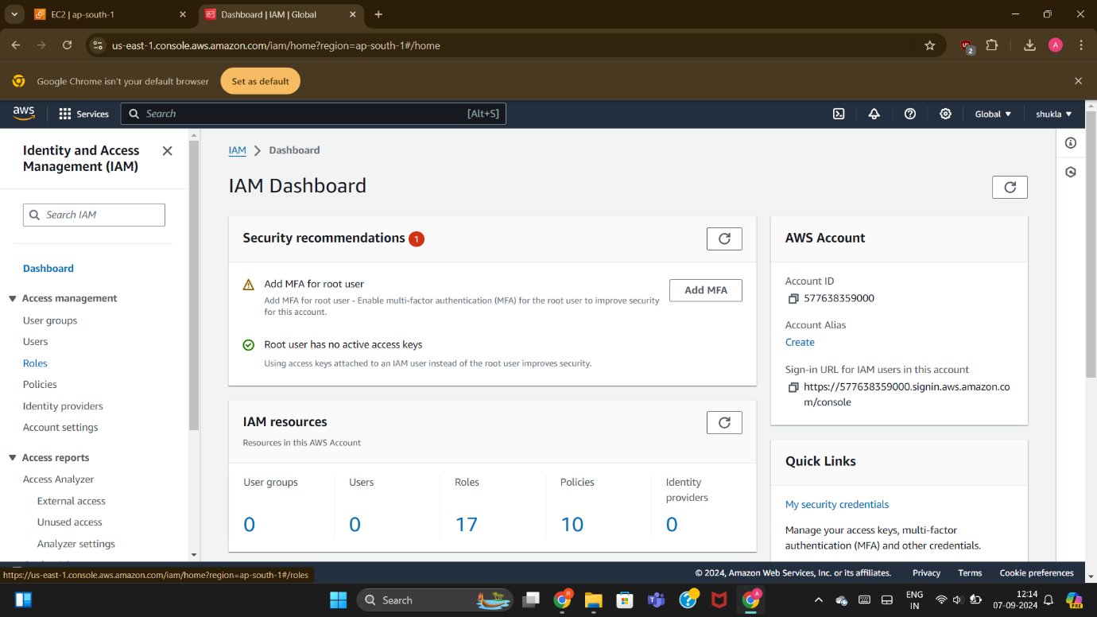

STEP 12:-

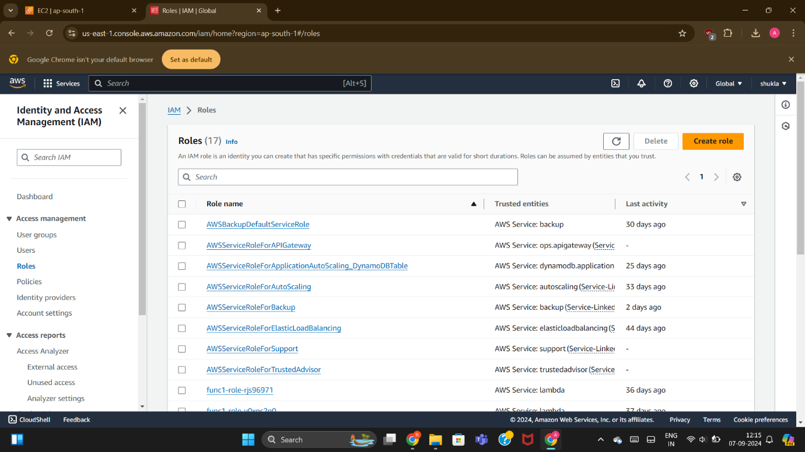

After that we will go to create role for creating role .

STEP 13:-

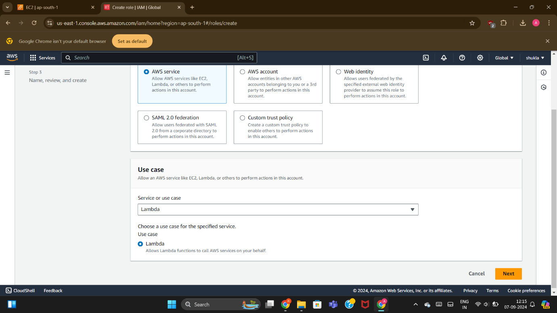

for the service it is by default selected as AWS service.

In the use case section we will select lambda as the service and then click on the next.

STEP 14:-

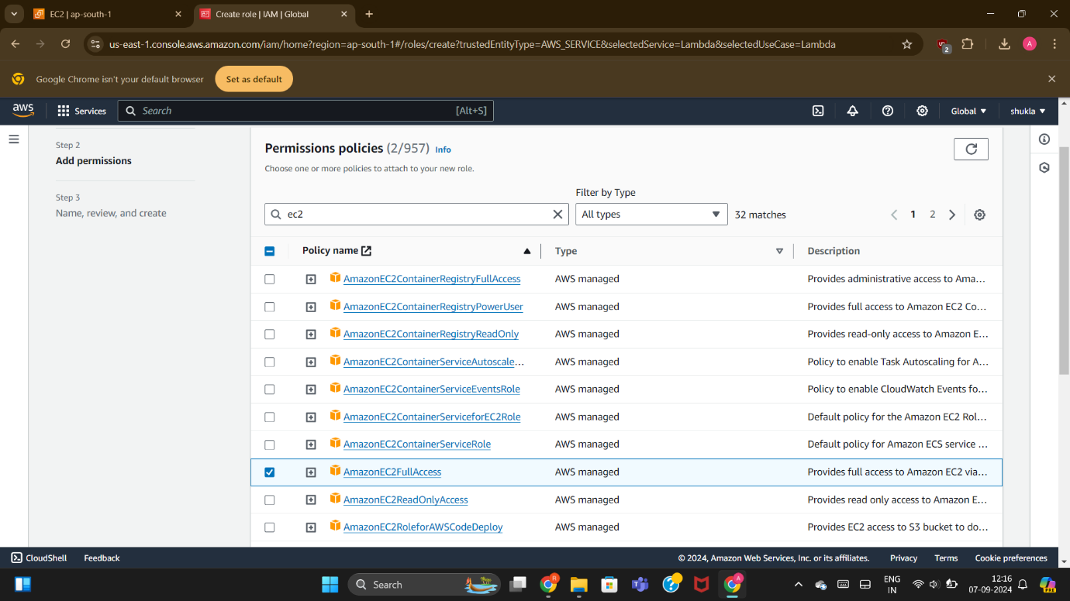

After that we will provide permissions to role created in order to link with EC2 service and Lambda Function. Permissions provided are:-

1. AMAZON FULL ACCESS
2. AMAZON EC2 FULL ACCESS

STEP 15:-

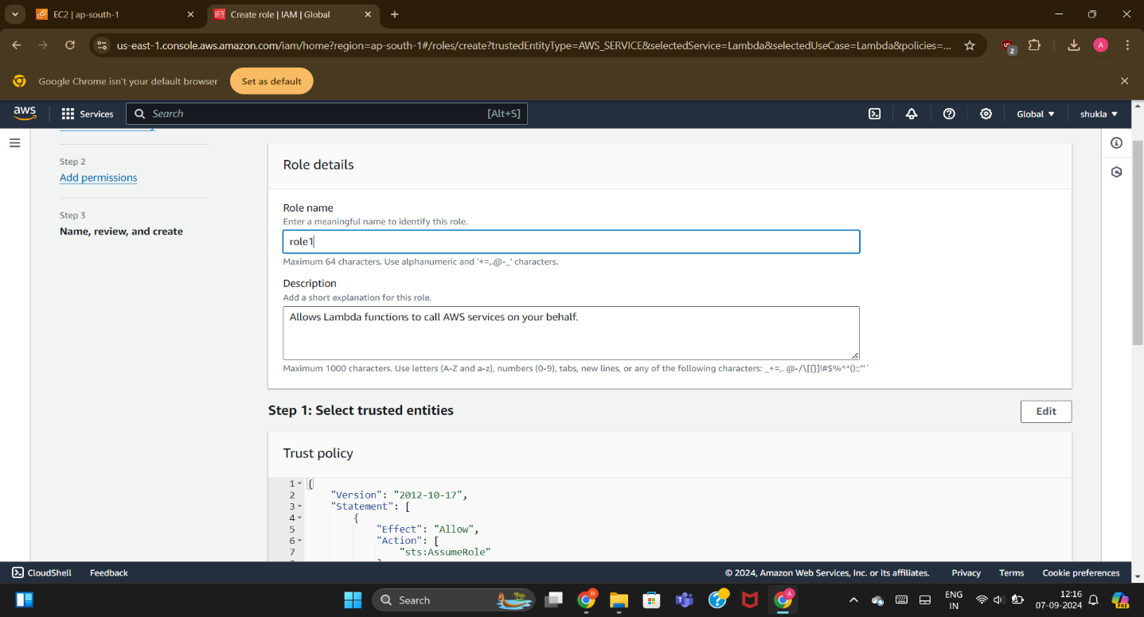

Name the role as “role1”.

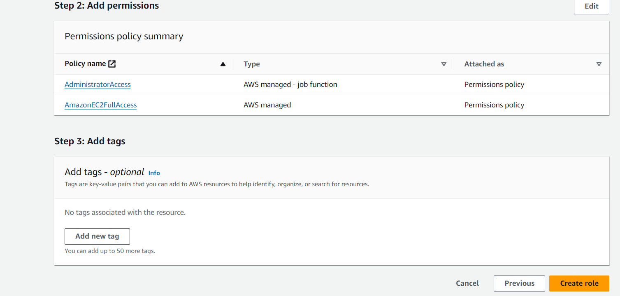

Then click on create role.

STEP 16:-

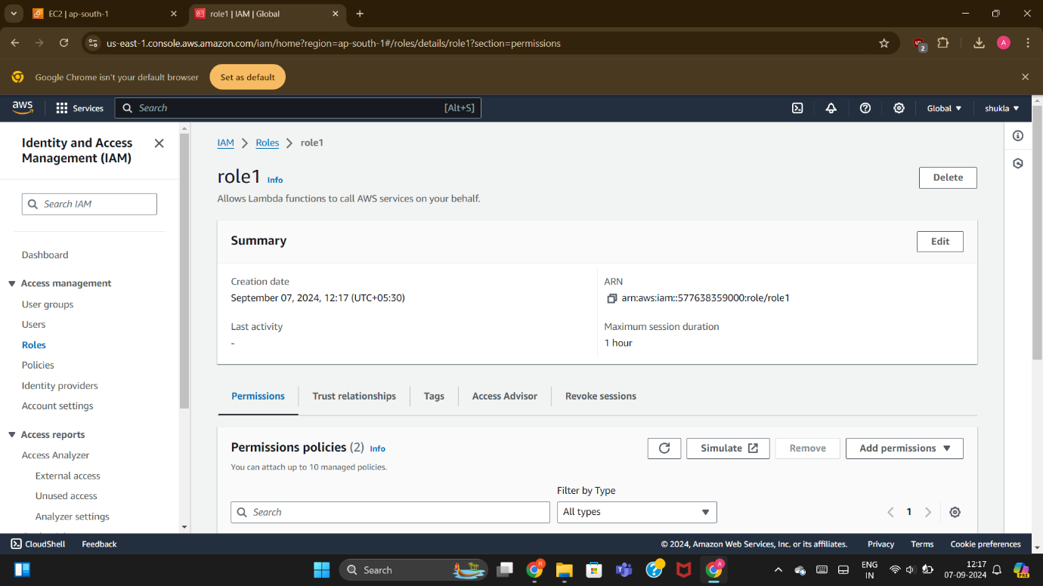

Role is now created for the lambda function.

STEP 17:-

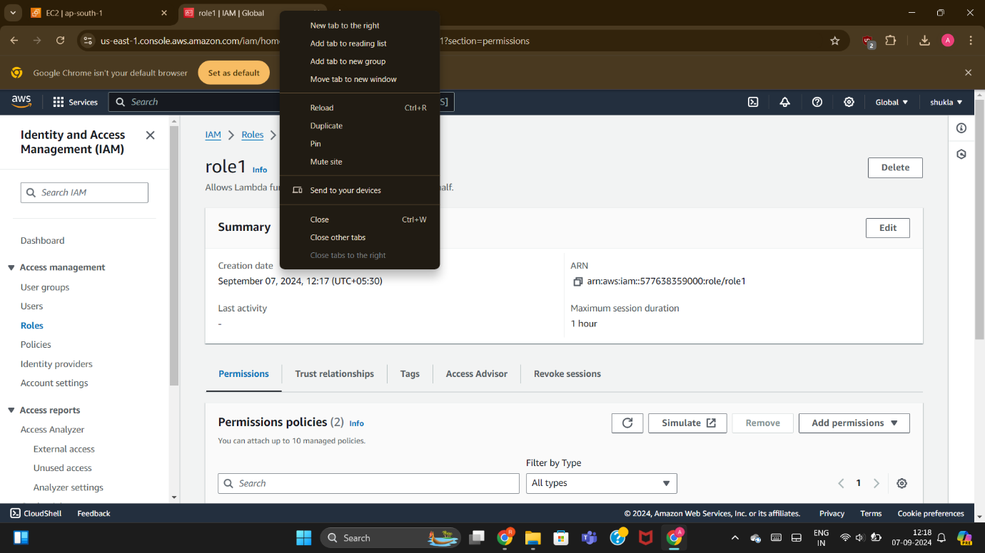

Now open a duplicate window in order to make function using Lambda Service of AWS.

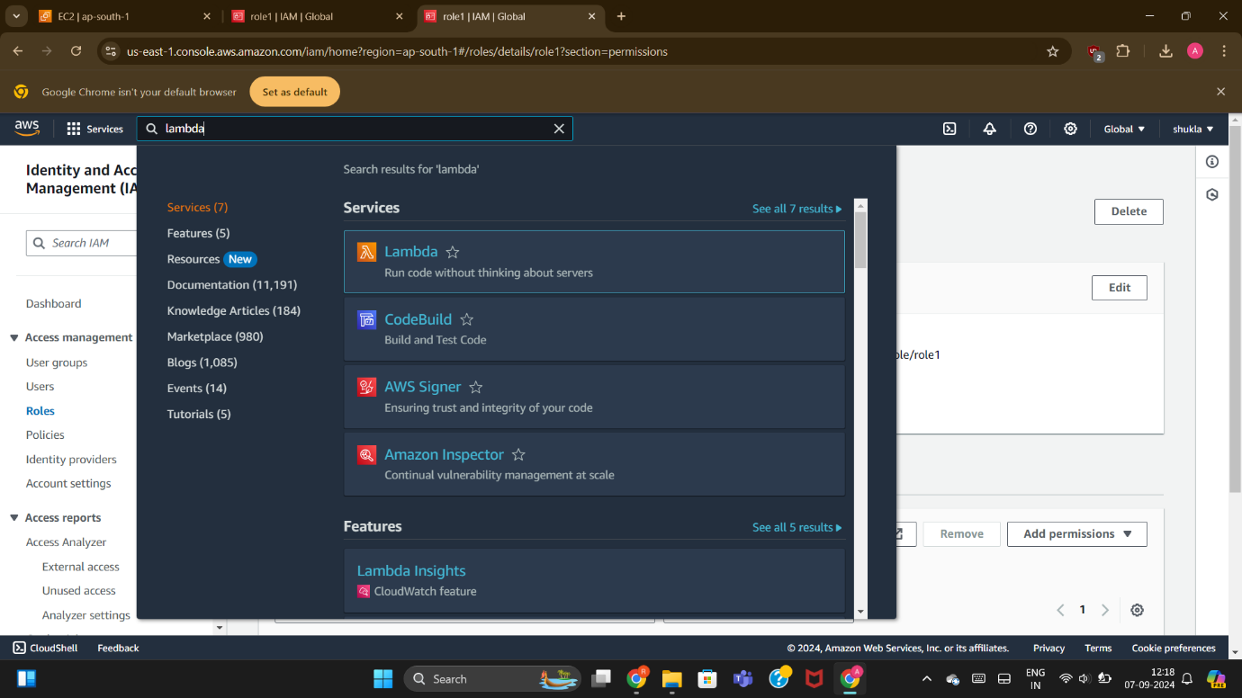

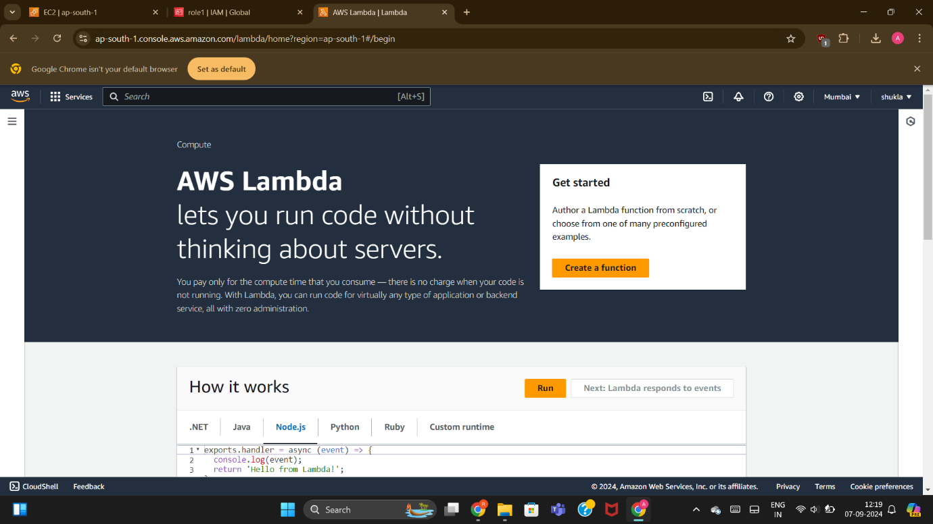

Create function of the lambda.

STEP 18:-

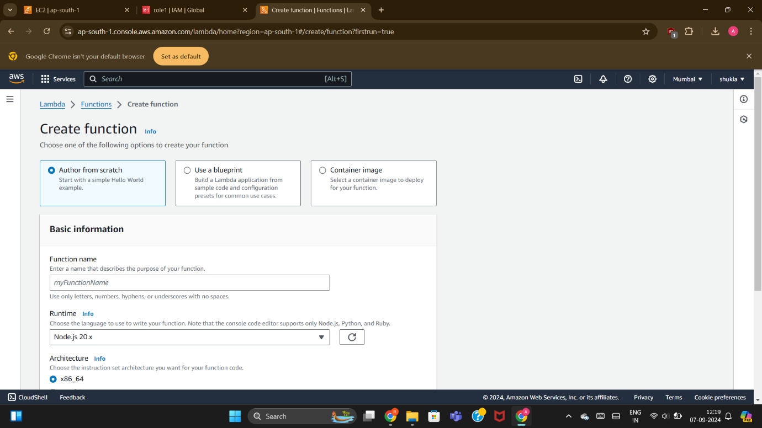

Name the function as “function1”.

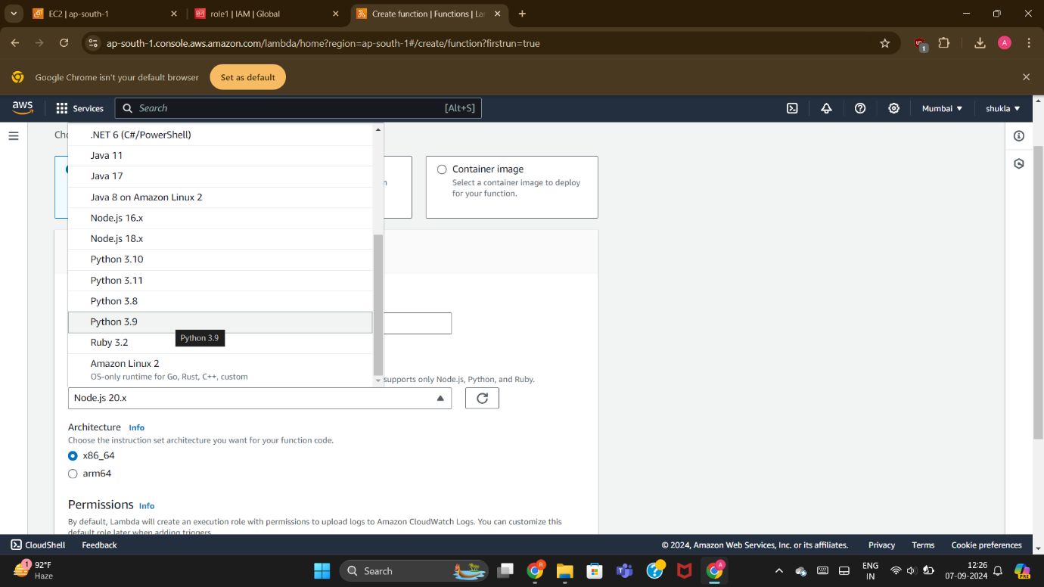

Select language of code as “python 3.9”.

STEP 19:-

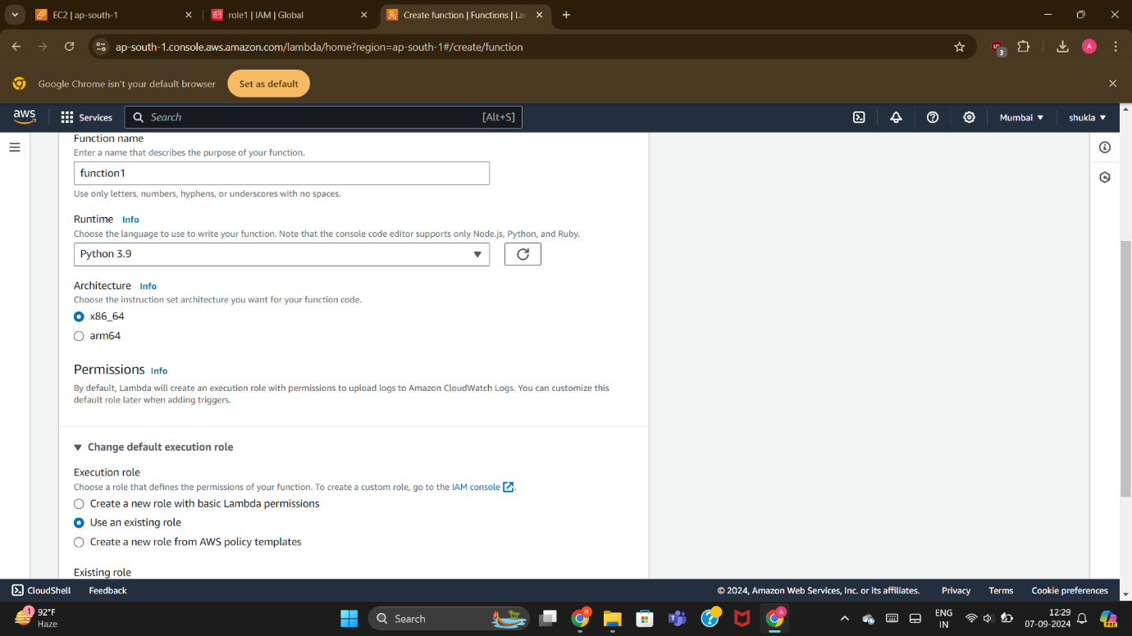

Click on the existing role and as option the role you have created earlier using IAM will occur in the option , select the role .

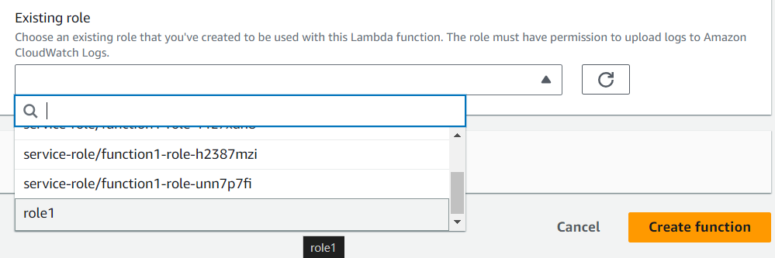

STEP 20:-

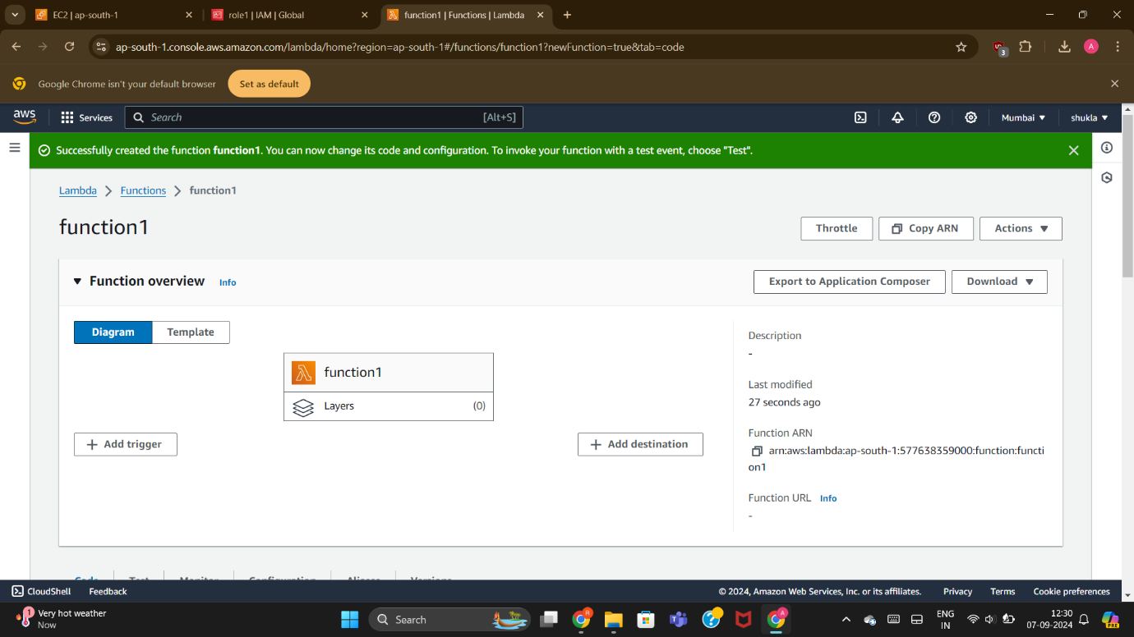

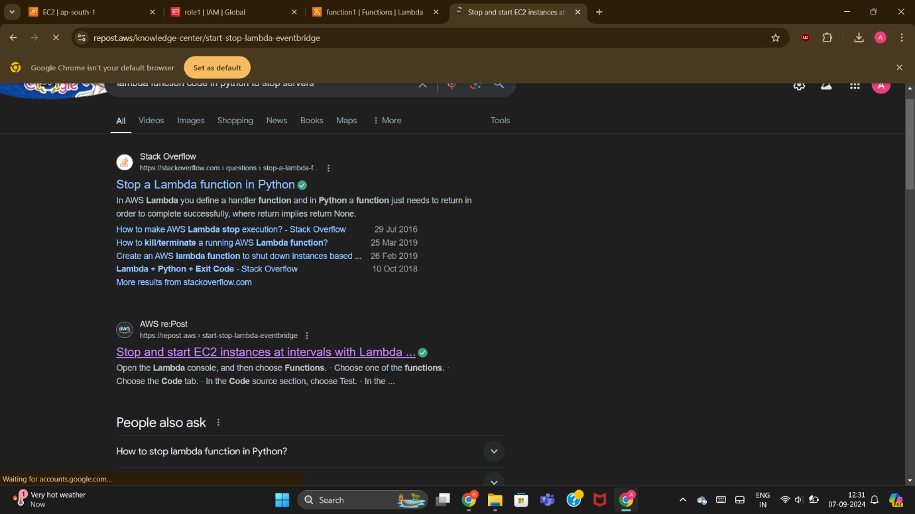

Search for the code in the new tab in the python language to stop the server as our server is running so here we will used the code to stop the server .

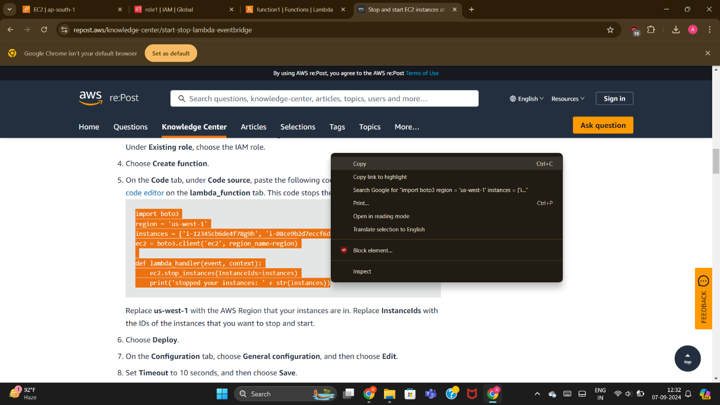

Copy the code to stop the server in the lambda function created earlier .

STEP 21:-

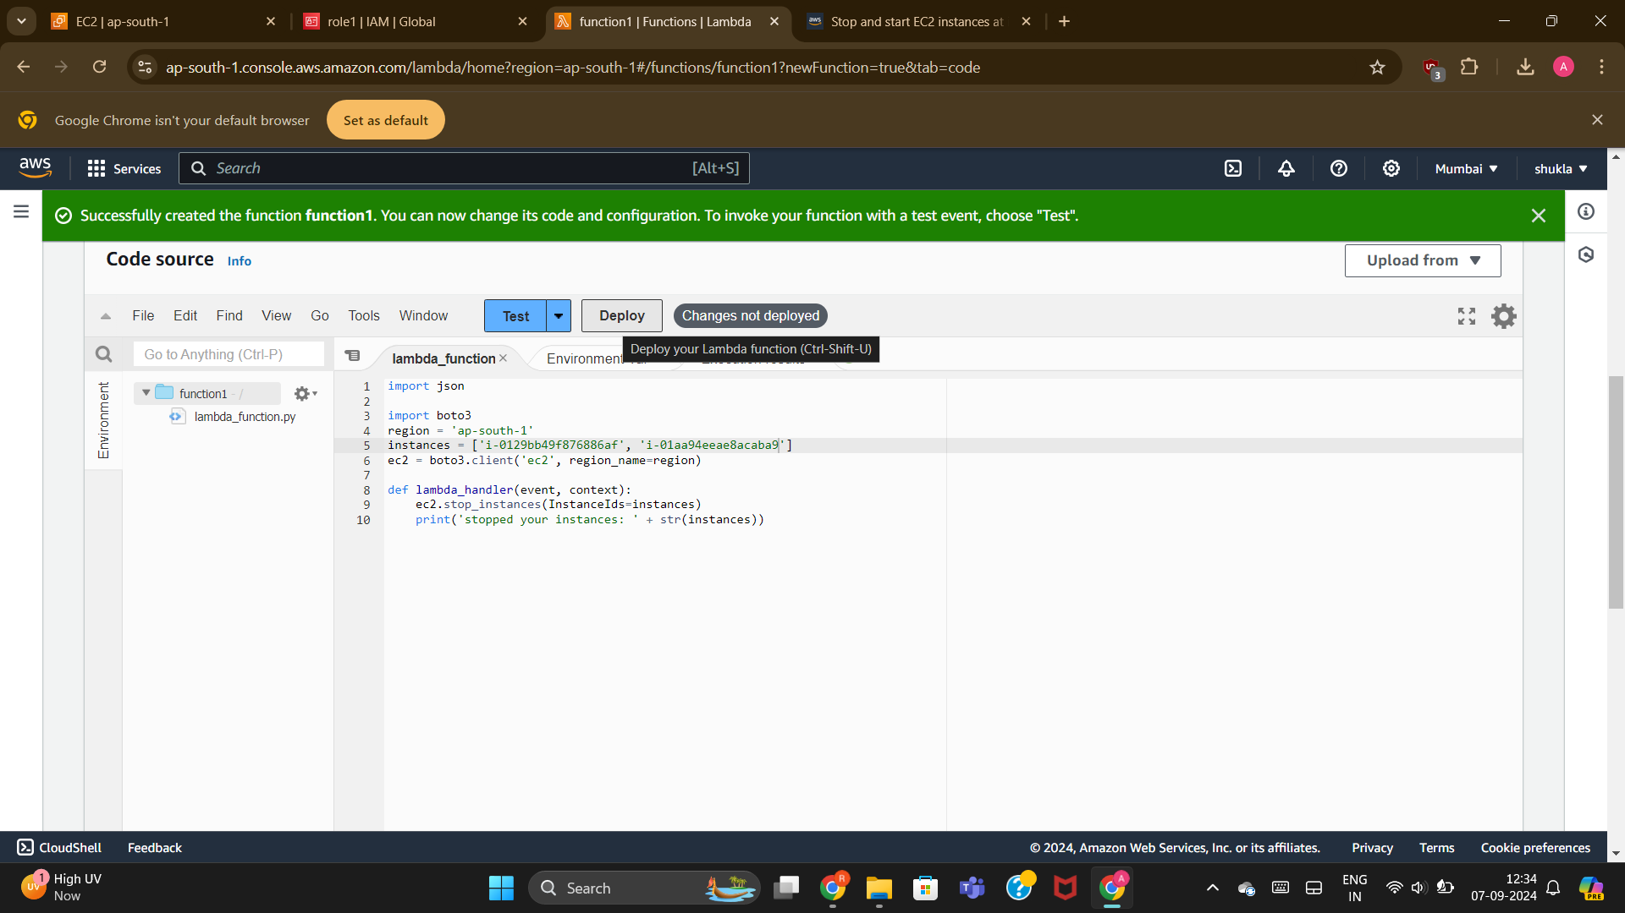

Now paste the code and change the region as “ap-south-1” and paste the instance id of both the servers in the code from instances.

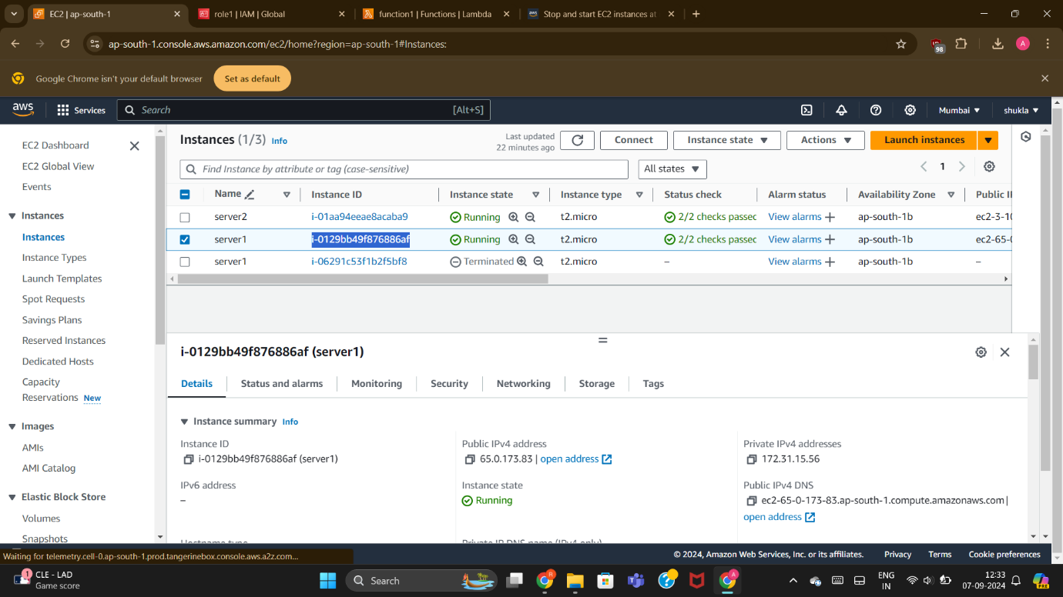

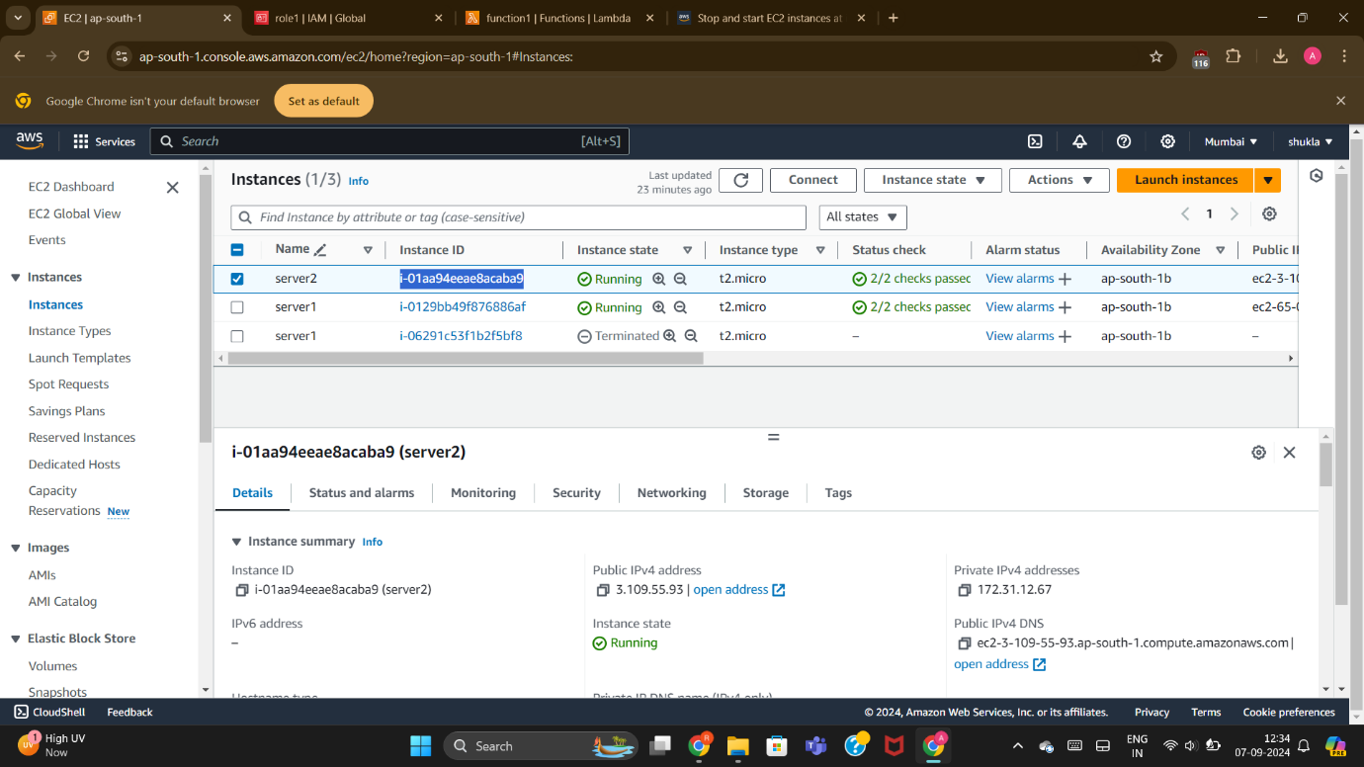

STEP 22:-



After that save the file and then deploy the code , it takes few seconds to get stopped .

Then we will check in the EC2 service that the servers which were earlier running now gets stopped using this code .

That’s the reason why lambda is known as serverless service.

